**TALC**

**HERO**

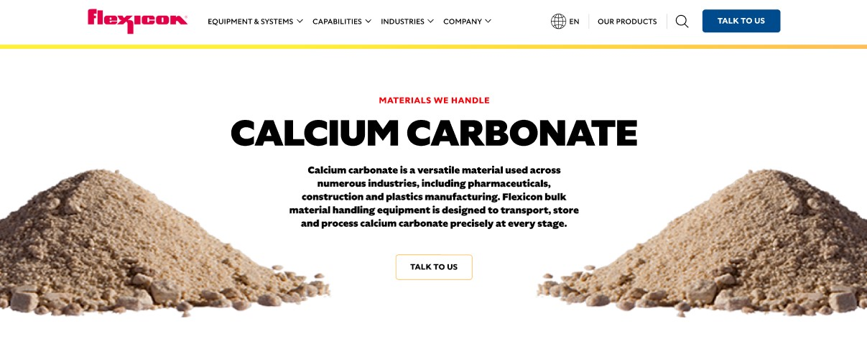

Talc is a soft, naturally occurring mineral used in a wide range of industries, from cosmetics and ceramics to plastics and paints. Flexicon bulk material handling systems are engineered to move, store, and process talc efficiently while minimizing dust and product loss.

**Button**: Talk To Us

**SHELF #1 - PRODUCT DESCRIPTION**

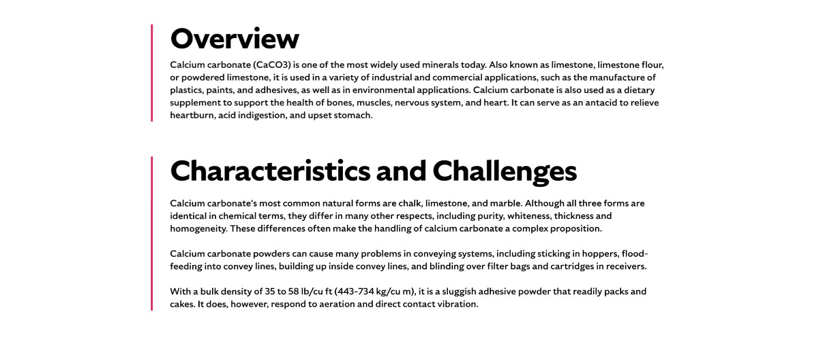

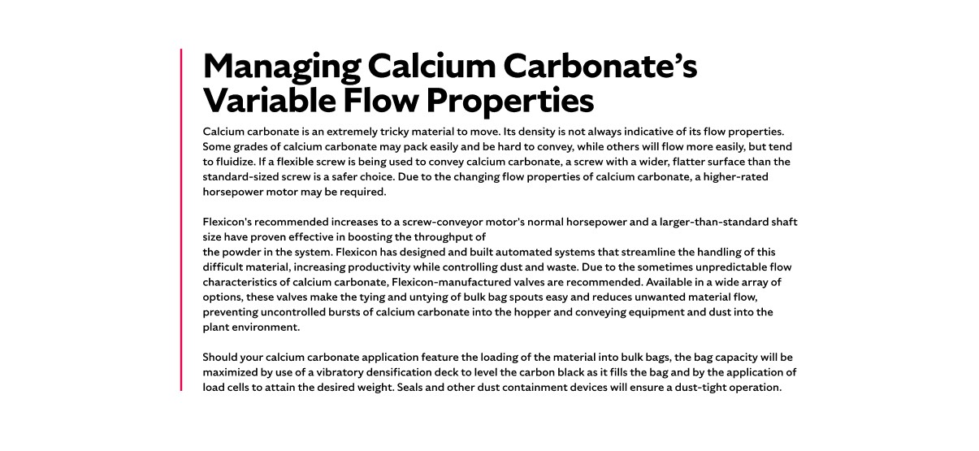

**Overview**Talc, often recognized as the main ingredient in talcum powder, is valued for its moisture-absorbing, lubricating, and astringent properties. It is widely used in personal care products, ceramics, plastics, paints, and paper manufacturing. Talc’s softness and chemical inertness make it ideal for applications requiring gentle handling and stability. Despite its versatility, talc must be handled with care to maintain product integrity and ensure workplace safety..

**Characteristics and Challenges**Talc is a semi-free-flowing powder with hydrophobic, chemically inert, and slippery properties. It tends to smear and fluidize, behaving like a liquid, and becomes extremely difficult to manage when wet. To maintain flowability and prevent handling issues, talc should be kept dry and conveyed gently to avoid over-aeration.

Effective talc handling requires airtight systems, dust control, and flow-aid devices. Bulk bag dischargers should include features like spring-loaded frames and bag activators to ensure complete discharge, while dust collectors help maintain air quality. Manual dumping stations need filtration and pulse cleaning, and hoppers may require vibrators or screens for safe, efficient flow. Proper sensor selection and moisture control are also essential for reliable system performance.

**SHELF #2 - FLEXICON SOLUTIONS**

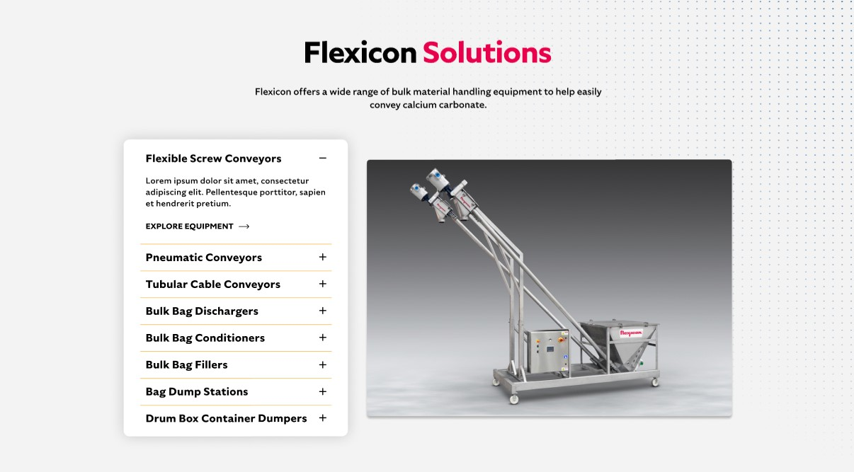

**Flexicon Solutions**

Flexicon offers a wide range of bulk material handling equipment to help easily convey talc.

* **Flexible Screw Conveyors**: Move talc gently through the system while reducing the risk of clogging, smearing, or material buildup inside the conveying components.
* **Pneumatic Conveyors**: Maintain a clean, enclosed transfer of talc by capturing airborne dust and cycling it back into the process stream through integrated filtration.
* **Tubular Cable Conveyors**: Ideal for tight plant layouts, these enclosed systems handle talc with minimal product degradation and reduced dust emissions.
* **Bulk Bag Dischargers**: Provide a controlled, dust-sealed method for unloading talc from bulk bags, with features that enhance material flow and operator safety.
* **Bulk Bag Conditioners**: Restore flowability to hardened talc by applying pressure to compacted bags, ensuring smooth and uninterrupted discharge.
* **Bulk Bag Fillers**: Deliver accurate, dust-controlled filling of bulk bags using vibration and sealing systems to achieve target weights and clean operation.
* **Bag Dump Stations**: Support manual addition of talc into processing lines with built-in dust collection and filtration to protect workers and maintain air quality.
* **Drum/Box/Container Dumpers**: Automate the transfer of talc from smaller containers into production systems while minimizing manual handling and dust release.

**SHELF #3: LIFETIME PERFORMANCE GUARANTEE**

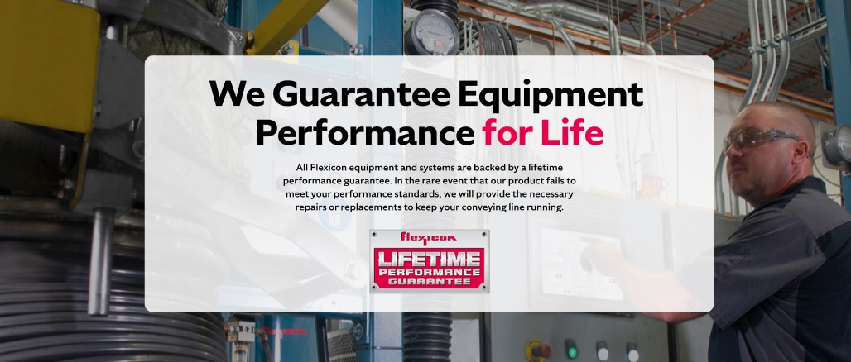

**Lifetime Performance Guarantee**

All Flexicon equipment and systems are backed by a lifetime performance guarantee. In the rare event that our product fails to meet your performance standards, we will provide the necessary repairs or replacements to keep your conveying line running.

**SHELF #4: CASE STUDIES**

